CORE AND MATERIALS (MATERIALS SCIENCE)
Metals and Alloys
Coins and magnetism
We are going to carry out two simple experiments that support different parts of the Core and Materials course. The first relates to the case study given on coins and counterfeiting. It is a very simple experiment that will introduce you to one of the important properties that certain metals can have – magnetism.

Equipment
Magnet

Materials
Coins – try to get as many as possible from different sources, both UK coins of different ages, any foreign currency (euros and any pre-euro European currency, US cents, any other overseas currency)

Method
- Put your coins into a pile

- Run the magnet across the pile

- Separate any coins that are attracted to the magnet and record their details

Coin | Appearance | Date
e.g. US 1 cent | e.g. Copper | e.g. 2001

Questions
For the UK coins that are magnetic, are these results consistent with the coin compositions in presentation given on coins and counterfeiting?
For the foreign coins that are magnetic, do some research and see if you would expect them to contain magnetic materials.
Is it possible that any of the coins you have examined are counterfeit?

Electrochemistry
This experiment supports the lecture on Electrochemistry given in the Chemistry part of the Core & Materials module. We are going to look at two aspects of electrochemistry, firstly to react away the oxide layer formed on copper coins that makes them look dull, and the to use to dissolved copper ions to plate an iron nail with a thin layer of copper metal.

Equipment
Ceramic or plastic bowl
Paper towels

Materials
Vinegar
Salt
Copper coins (1p and 2p coins, as used and dull as possible)
Ungalvanized iron nail
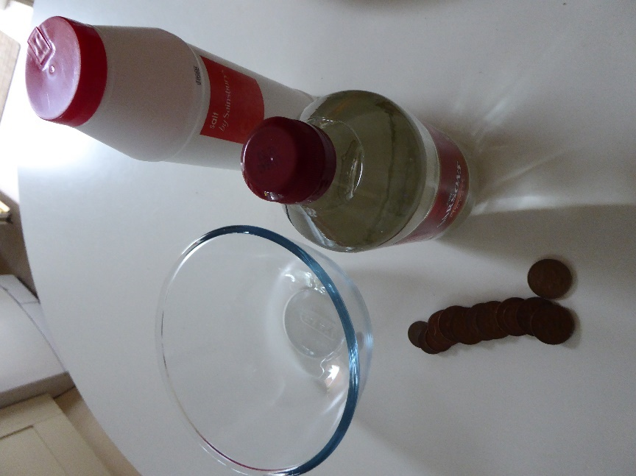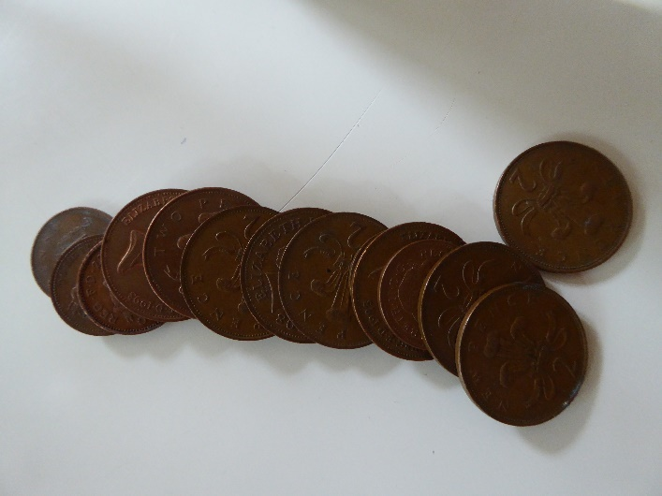

Method
- Fill the bottom of the bowl with vinegar, stir in a teaspoon of salt, and then put 10-15 copper coins in.
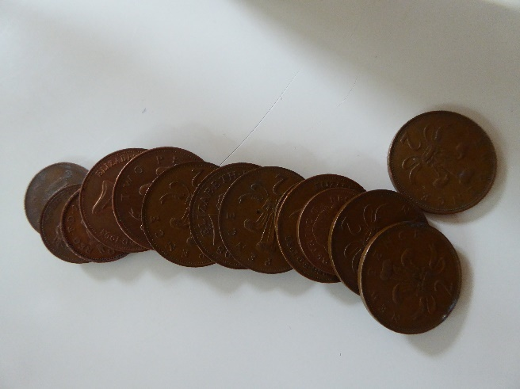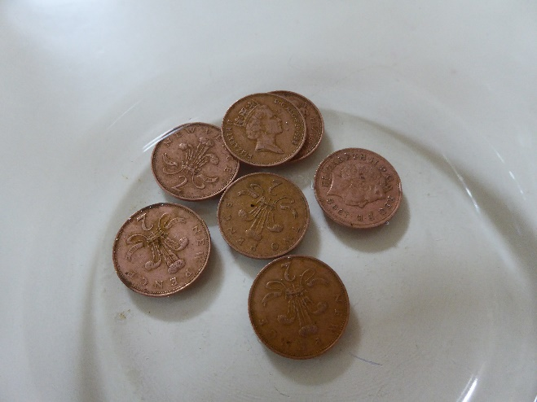

- Leave the copper coins in the solution for five minutes, then take them out and put them on a paper towel to dry.

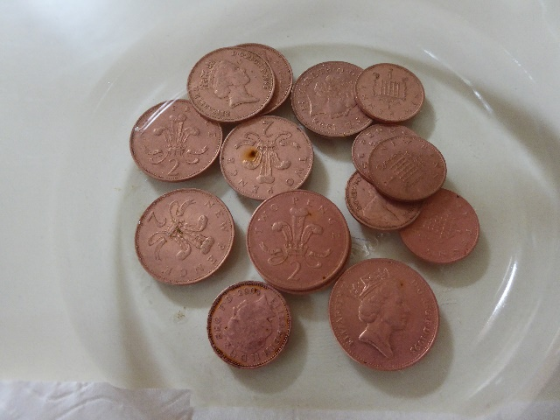
- The copper coins should now be much shinier than before. This is because vinegar and sodium chloride react to form hydrochloric acid. This reacts with the copper oxide formed on the surface of the coins to reveal a fresh copper surface. The reactions occurring are:

CH₃OOH + NaCl → CH₃OONa + HCl _{(aq)}
CuO _{(s)} → Cu²⁺ + O²⁻ (aq)

However, if you don’t rinse or dry the clean copper coins, after a while you should see a blue layer appear on them, due to re-oxidation of the copper

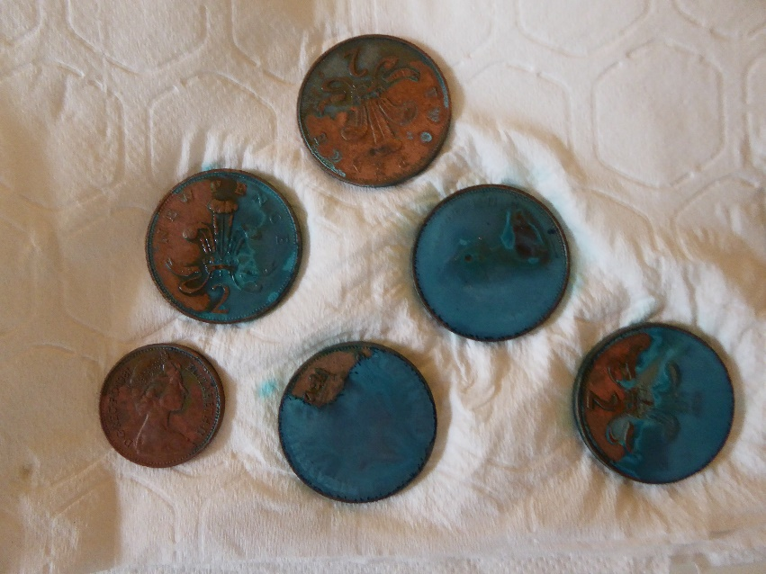

- Now place an ungalvanized iron nail into the salt and vinegar solution you have just used to clean the copper coins. If you look closely, you will see tiny bubbles along the sides of the nail. Let it sit for 30 minutes and then check to see if there is a dark-brown layer of copper on it.

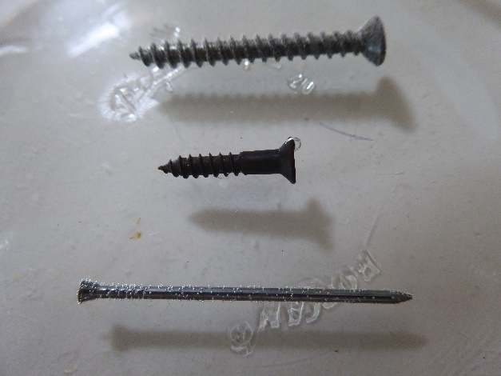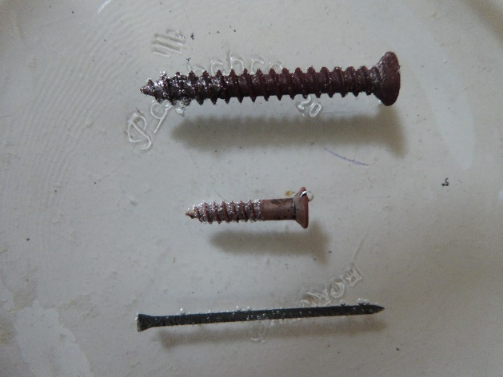

- The vinegar solution contains copper ions in solution from the copper coins that it cleaned. When the solution reacts with the nail, it a chemical reaction occurs that leaves a copper coating on the nail:

Cu²⁺ _{(aq)} + Fe⁰_{(s)} ↔ Cu⁰ _{(s)} + Fe²⁺ _{(aq)}

When you take the nail out of the solution, the copper will be somewhat sticky; you can put it on a paper towel to dry. Your nail might not be entirely coated, but it should have enough copper on it to see.
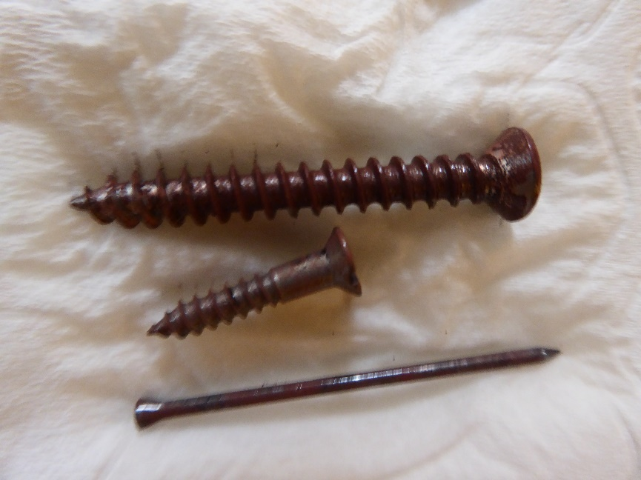

Polymers
Introduction
In this experiment, we are going to make a polymer. As taught in the lecture, a polymer is a long chain formed by a repeating molecule. In polyethylene, the repeat molecule (the ‘monomer’) is ethylene. In the polymer you are going to make, the repeat unit is casein, which is one of the main molecules that can be found in milk.

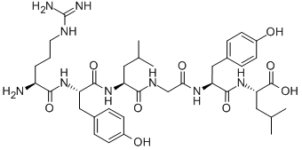
The polymer you are going to make is more than just a novelty – from the early 1900s until about 1945, ‘milk plastic’ was commonly used to make many different plastic ornaments. This included buttons, decorative buckles, beads and other jewellery, fountain pens, the backings for hand-held mirrors, and comb and brush sets.
We are going to make the polymer by adding an acid, in this case vinegar, to milk.

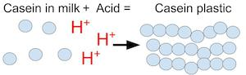
After you add the hot milk to the vinegar, small, white chunks—or curds—should become visible in the mixture. This is because adding an acid (such as vinegar) to the milk changes the milk's pH (acidity) and causes the casein molecules that are present in small clusters to open out and polymerise into a long chain, thereby curdling the milk. You can use a spoon to separate the curds from most of the liquid, and after a bit of additional drying you can knead the curds into a ball and mould it into different shapes of ‘milk plastic’.

Equipment
Measuring cup
Oven or hot plate
Saucepan (or a microwave and microwaveable container)
Heat resistant mug
Measuring spoons
Paper towels
Baking tray
Spoon

Materials
Milk (whole milk is best, it contains more casein)
White vinegar
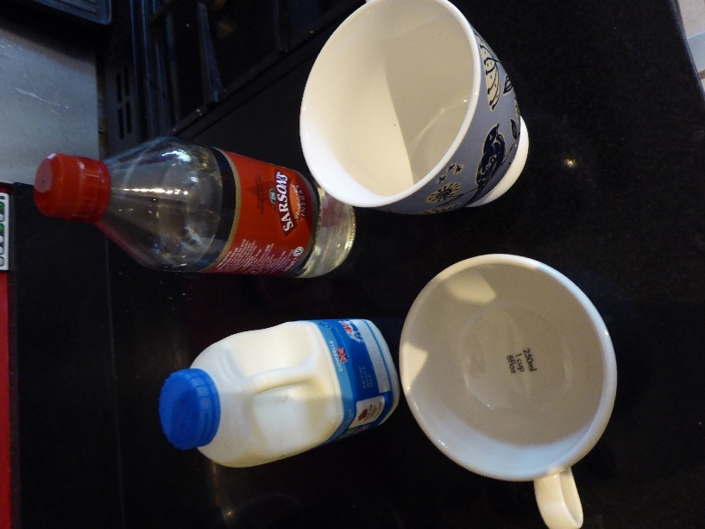
Method
  - Heat one cup of milk in a saucepan until it is steaming hot. (Alternatively, you can microwave the milk in a microwaveable container by warming it at 50 percent power for five minutes. It should be about the same temperature as milk you would use to make hot cocoa; heat longer if needed).

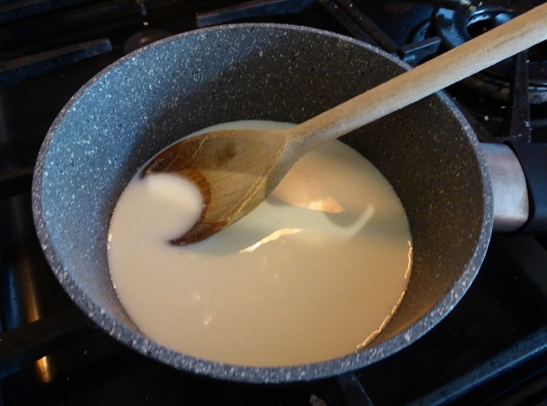

  - Add four teaspoons (tsp.) of white vinegar to a heat resistant mug.

  - Add the cup of hot milk to the mug. You should see the milk form white clumps that are called curds.

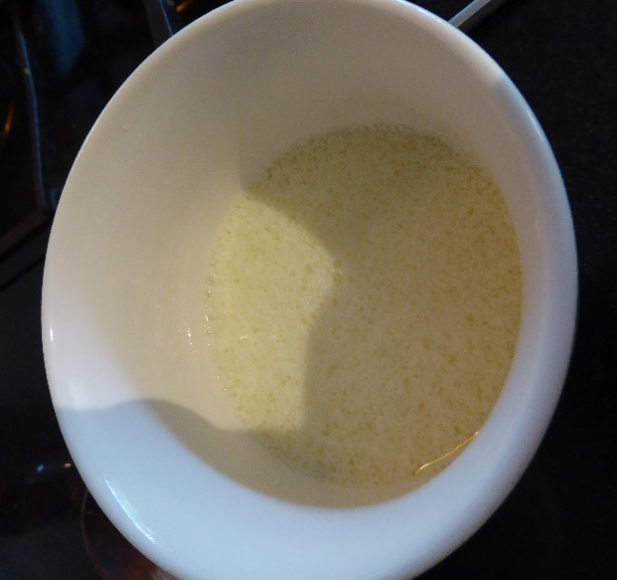

  - Mix the mug slowly with a spoon for a few seconds.

  - Stack four layers of paper towels on a baking tray.

  - Once the milk and vinegar mixture has cooled a bit, use a spoon to scoop out the curds. You can do this by tilting the spoon against the inside of the mug to let excess liquid drain out while retaining the curds in the spoon. Collect as many curds as you can in this way and put them on top of the paper towel stack.

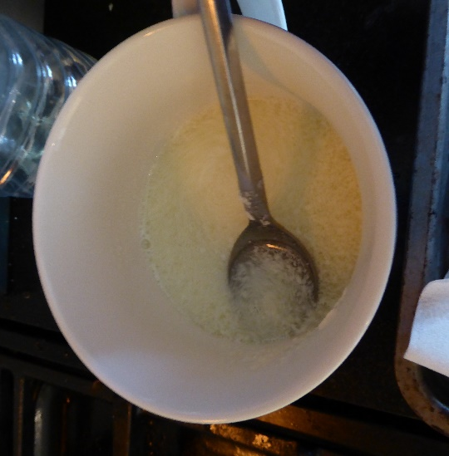

  - Fold the edges of the paper towel stack over the curds and press down on them to absorb excess liquid. Use extra paper towels if needed to soak up the remaining moisture.

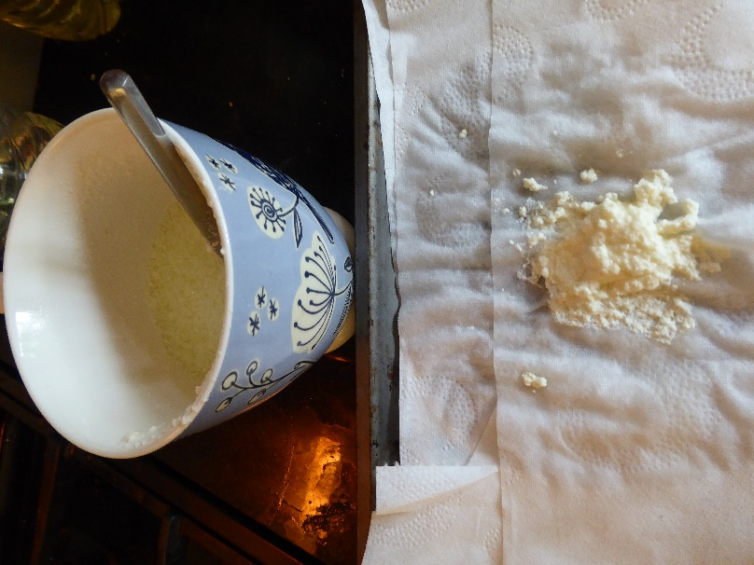

  - Knead all of the curds together into a ball, as if it were dough. What you have in your hands is casein polymer.

  - The casein polymer can be coloured, shaped or moulded (within an hour of making the plastic dough) and left to dry on paper towels for at least 48 hours. Once it has dried, the casein polymer will be hard.

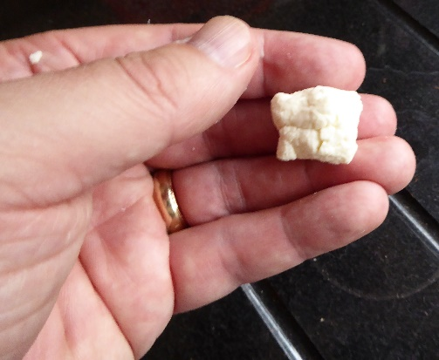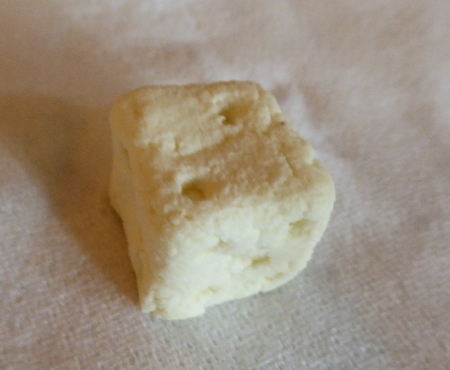

Variables to consider:
What is the effect of the amount of vinegar used on the yield of casein plastic? Try repeating the experiment using one tsp., two tsp. or eight tsp. of the vinegar mixed into the one cup of hot milk.
What is the effect of changing the acid used to make the casein plastic? Try repeating the experiment with 4 tsp. of another kitchen acid, such as lemon juice, orange juice or apple juice.
What is the effect of changing the temperature of the milk on the yield of casein plastic? Try using cold milk, or milk that is heated to a temperature close to its boiling point.

Paints and Inks
Ink chromatography
In this experiment we’re going to look at the composition of inks using paper chromatography. Chromatography is used widely in chemistry and in the biological sciences to separate mixtures of compounds, and to identify unknown substances. All types of chromatography employ two different immiscible (non-mixing) phases in contact with each other. One of the phases is moving, the mobile phase, and the other is not, the stationary phase. Gas chromatography and liquid chromatography are widely used in forensic applications. In paper chromatography, a solvent (the liquid) moves from one end of a piece of paper to the other end, as the paper absorbs it. The solvent is the mobile phase because it is moving, and the paper is the stationary phase. The dyes from the ink that have dissolved in the solvent are carried along in the mobile phase but drop out at different points as the solvent moves up the paper.
In this practical experiment paper chromatography is used to separate the coloured dyes in different types of pen inks. To do this we will deposit spots of the inks to be separated close to the edge of a piece of filter paper and then wet the filter paper with solvent. The solvent travels up the paper by capillary action, carrying the mixture of dyes in the ink with it. Separation occurs because different chemicals in the ink travel different distances, depending upon whether they have a stronger attraction for the mobile phase, the solvent, or for the stationary phase, the paper. When the solvent has moved the entire length of the paper, the paper is removed from the solvent and dried. Once developed, the paper, called a chromatogram, will contain spots of different chemicals located at different positions on the paper. The colour and location of each chemical spot can be used as a basis for identification because it can be matched with the colour and location of known compounds subjected to the same conditions.
Different pen inks are made of different combinations of coloured dyes. Although the inks may all look the same colour when deposited on the paper, the chemicals present can be separated out by chromatography allowing you to see the differences.

Equipment
Chromatography paper or filter paper (we can use coffee filter paper cut into strips as a substitute if necessary)
Wooden skewer/thin wooden stick
Pencil
Ruler
A drinking glass or tall glass jar
Paper clip (optional)
Cling film (optional)

Materials
A range of pens including coloured marking pens (both permanent and dry erasable), ballpoint pens of different colours and sources, gel pens, felt-tip pens.
A range of solvents (e.g. water, vinegar, white spirit, methylated spirit, acetone (nail polish remover)).

Method
Health & Safety Information: Use any flammable solvents such as methylated spirit, white spirit or acetone in a well-ventilated space, away from naked flame and avoid breathing in any vapours
- Cut a strip of filter paper between 2 - 4 cm wide and long enough to reach to the top of your glass or beaker, plus about another 5 cm. The bottom edge of the paper should be straight and the strip should not touch the sides of the jar or glass.

- The filter paper should be just long enough so that the paper can be suspended from a pencil or wooden skewer placed across the top of the jar, and the bottom of the paper stops just short of touching the bottom of the jar.

- Label each piece of filter paper with pencil, recording which solvent you are using

- Measure about 2 cm from the bottom of the filter paper and draw a pencil line across the width of the paper. Place separate spots of ink from pens you want to test about a centimetre apart across the pencil line on the filter paper. Label each ink spot with pencil. Allow the spots to dry and then repeat to build up a greater quantity of ink in each spot.

- Add the selected solvent to the jar/glass to a depth of about 1 cm.

- Carefully lower the filter paper with the marker ink dots, secured with tape or a paper clip to a pencil or wooden skewer, into the jar with bottom edges just barely submerged in the solvent. Ensure that the bottom of the paper is, but the marker dots are not, in direct contact with the solvent.

- Allow the solvent to creep up the paper (elute). This will take about 15 minutes but may take longer depending on the solvent and paper type. Remove your chromatography paper from the solvent once it has reached one to one half cm from the top. Do not allow the solvent to reach all the way to the top of the filter paper

- Hang the chromatograms and allow them to fully dry before making measurements.

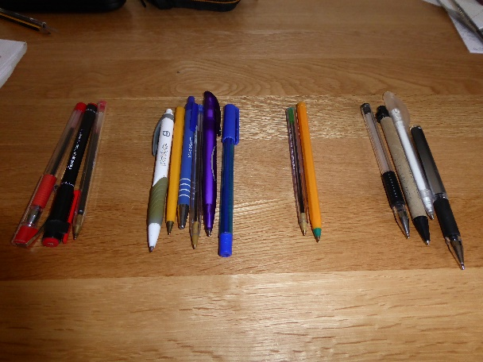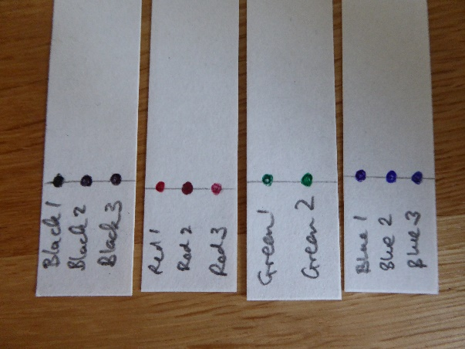
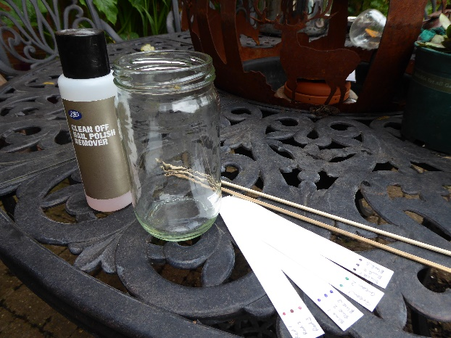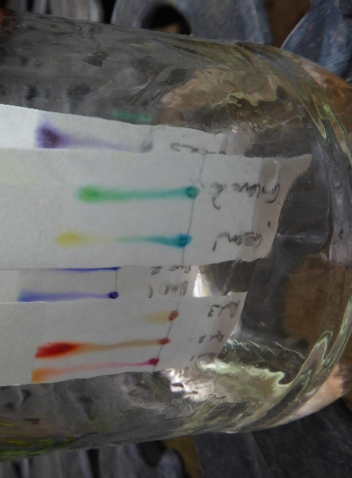
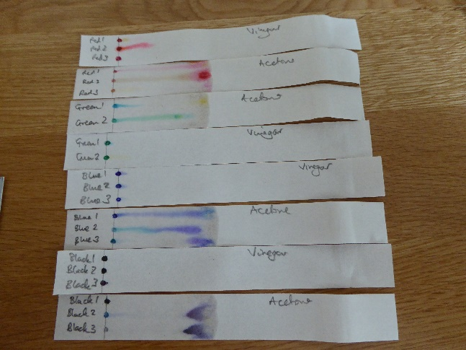
Analysis of results
In chromatograpy, the symbol R_{f} is used to denote the position of a dissolved component on a chromatogram relative to the distance the solvent moved. This R_{f} value is a quantitative reflection of the physical interaction of each component with the mobile phase (the solvent) and the stationary phase (the paper).
R_{f} = D_{p} / D_{s}
R_{f} = distance pigment moved / distance solvent moved
Look at the spots of ink that are present on the chromatogram. Draw pencil ellipses around each region that appears to represent a distinct component of the ink. Measure the distance from the origin of the marker dots (the pencil line) to the centre of the eluted marker ink. Divide that number by the distance the solvent moved, i.e. from the origin to the solvent front (the highest point that the solvent reached). Fill in a data table for R_{f} values for the components in each of the inks tested and identify which inks are made of a single component and which have multiple dyes present.
E.g.:
Ink | Solvent | Spot colour | D_{p} | D_{s} | R_{f}
e.g. Bic black ballpoint | e.g. Acetone | e.g. Blue | e.g. 30 mm | e.g. 50 mm | e.g. 0.6

Variables
Try repeating the experiment using a different solvent and look at whether the inks separate in the same way. For example, start using water (not all types of ink will dissolve in this solvent), then repeat with white vinegar, then white spirit or acetone.
What effect does the solvent have on the ink separation and Rf values you obtain?
Does the experiment still work if you try it with plain white copier paper?

RESEARCH METHODS

Variation in larger populations
In Forensic Science we are more often talking about variations in larger populations of materials such as pollen, soil particles, fibres, glass refractive indices. In this experiment we are going to look at measuring the distributions of particles in some naturally occurring materials and obtaining sets of data that can be compared with those obtained by other students for the same material, and with data that you have obtained for other materials.

Equipment
USB microscope
Calibration scale (from USB microscope kit) or graph paper (download and print from online templates if not available)

Materials
Table salt
Other particulate materials – as many as you wish from:
Granulated sugar
Caster sugar
Ground spice (e.g. turmeric, cumin, pepper)
Sand

Method

- Place the calibration scale onto a sheet of white paper under your USB microscope, turn the LED lights down so that they turned off, focus the microscope with a reasonably short distance between microscope and the surface, and take a picture (alternatively, use a fine scale (1mm) graph paper as your backing material).
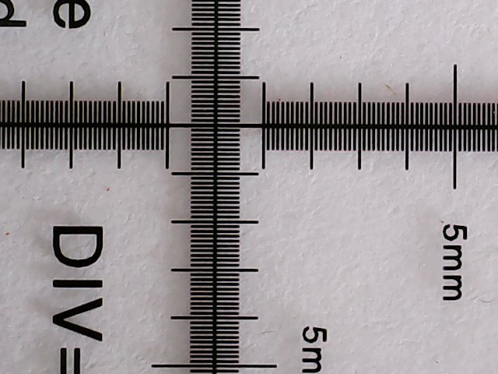
- Leave the camera set up as it was for photographing the calibration scale. Take a pinch of your chosen material and place it onto the surface with the scale present (either onto a sheet of paper with your calibration scale, or directly onto a finely ruled piece of graph paper). The particles should be quite closely packed, but not in a pile so that particles are on top of each other.

- Focus the image and take a picture.

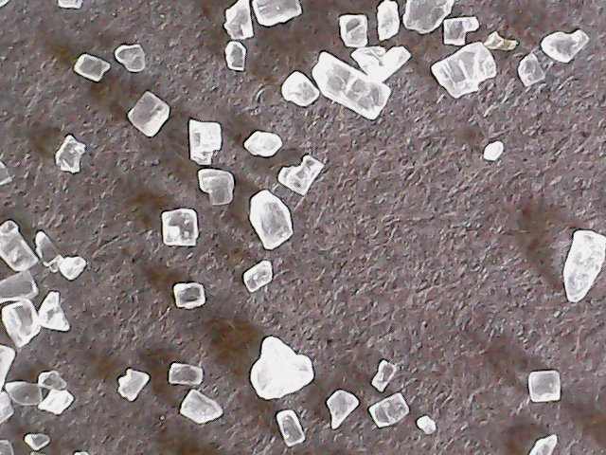

- Move to field of view slightly so you are looking at a different group of particles. Take another picture. KEEP THESE IMAGES – YOU WILL USE THEM IN SUBSEQUENT EXERCISES USING IMAGE J SOFTWARE

- Repeat the process until you have 5 pictures covering different groups of particles. Make sure you have a scale in each image that you have taken.

- Download the calibration software that comes with the USB microscope (Coolingtech). Use the image you have taken of the calibration scale to produce a calibration that can be used for all subsequent images.

- Import the images you have taken of the particles and measure the width of all of the particles that are within view. Alternatively, use the scale within your image to make an estimate of this value.

- Record the dimensions for 50 representative particles using the table below

Particle | Width | Particle | Width | Particle | Width | Particle | Width
1 |  | 15 |  | 29 |  | 43
2 |  | 16 |  | 30 |  | 44
3 |  | 17 |  | 31 |  | 45
4 |  | 18 |  | 32 |  | 46
5 |  | 19 |  | 33 |  | 47
6 |  | 20 |  | 34 |  | 48
7 |  | 21 |  | 35 |  | 49
8 |  | 22 |  | 36 |  | 50
9 |  | 23 |  | 37
10 |  | 24 |  | 38
11 |  | 25 |  | 39
12 |  | 26 |  | 40
13 |  | 27 |  | 41
14 |  | 28 |  | 42

- Repeat the same exercise for one other on the particle types suggested (e.g. granulated sugar
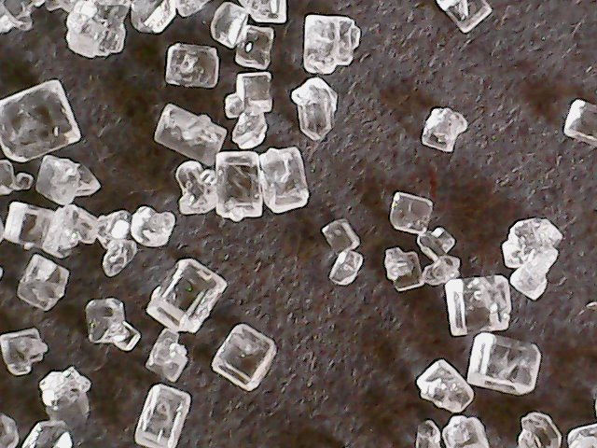

Particle | Width | Particle | Width | Particle | Width | Particle | Width
1 |  | 15 |  | 29 |  | 43
2 |  | 16 |  | 30 |  | 44
3 |  | 17 |  | 31 |  | 45
4 |  | 18 |  | 32 |  | 46
5 |  | 19 |  | 33 |  | 47
6 |  | 20 |  | 34 |  | 48
7 |  | 21 |  | 35 |  | 49
8 |  | 22 |  | 36 |  | 50
9 |  | 23 |  | 37
10 |  | 24 |  | 38
11 |  | 25 |  | 39
12 |  | 26 |  | 40
13 |  | 27 |  | 41
14 |  | 28 |  | 42

Questions
What is the mean and standard deviation for your measurements on salt crystals?
Answer:
What is the mean and standard deviation for your measurements on (sugar) crystals?
Answer:
Are there significant differences between the mean and standard deviations for your salt particles and the other particle type that you have measured?
Answer:
Are there significant differences between the mean and standard deviations for your salt particles and the measurements taken by your colleagues for the same type of material?
Answer:

Field studies
This very basic experiment introduces you to the approaches that can be used in a project where samples are being collected from different sites outside of a laboratory environment, and the analysis and comparison of those samples being used for purposes such as identifying differences between locations, identifying an underlying background level of a substance of interest, or trying to pinpoint a location from a unique combination of materials.

Equipment
USB microscope
Scissors
Pen

Materials
Roll of clear adhesive tape
Clear plastic bag (e.g. freezer bag)

In the following experiment you will be collecting samples of dust that have settled on surfaces in a range of locations and comparing the populations of materials that you find in each sample.
The locations to be sampled can be selected by you, it is recommended that you choose at least 5 different locations, including some indoor (e.g. bedroom, bathroom, kitchen, living room) and some outdoor (e.g. garden, park, woodland, urban area).
You will need to find surfaces that are horizontal, reasonably smooth, and have been kept reasonably dry so that particulate matter can settle on it. In outdoor locations this may be items such as stones, or the tops of railings/fencing)

Method
- Identify the area to be sampled

- Peel a length of clear adhesive tape ~4cm long from the roll, folding the first 1cm back on itself to form a tab that you can use to handle the lift.

- Cut the length of tape from the roll and place it on the area of dust you wish to lift. Smooth it down with your fingers, eliminating air bubbles.

- Peel the lift from the surface and stick it down on the clear plastic bag, smoothing it in place to eliminate any air bubbles and creases.

- Repeat the process for other areas/locations that you wish to lift. Clearly mark each lift so you know where it has been taken from.

- Using the scissors, trim the plastic bag away so that you have a transparent lift with the particles you have lifted trapped between the clear tape and the clear plastic of the bag.

- Place this lift over a white sheet of paper and place it under your USB microscope

- Conduct a search of the materials lifted from each surface. Either do this by searching in ‘live’ mode, or taking a series of images. Whichever method you use, be consistent and continue to use this method through the course of this experiment.

- Record your findings in a summary table – an example is given below, add or removed rows as appropriate

Location 1
Material | Secondary descriptor | Number present
Fibre type 1 | e.g. red twisted fibre
Fibre type 2
Fibre type 3
Skin cells
Mineral particle 1 | e.g. sand, clay
Mineral particle 2
Pollen grain 1 | e.g. yellow, round grain
Pollen grain 2
Seed 1 | e.g. dandelion seed
Seed 2

Compare and contrast the populations that you find in the different locations, for example look at differences in the occurrence of a particular fibre in different rooms of the house, look at the occurrence of particular pollen grains and seeds at different outdoor locations.
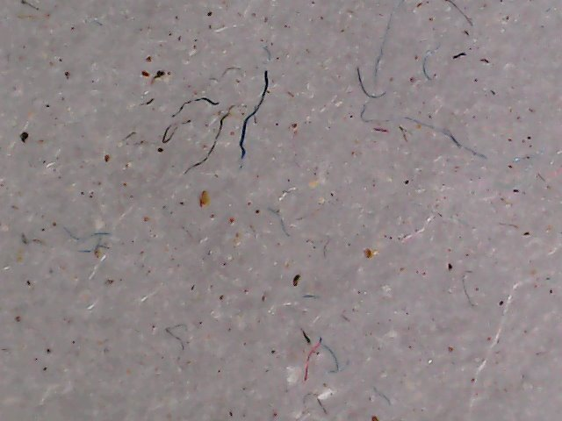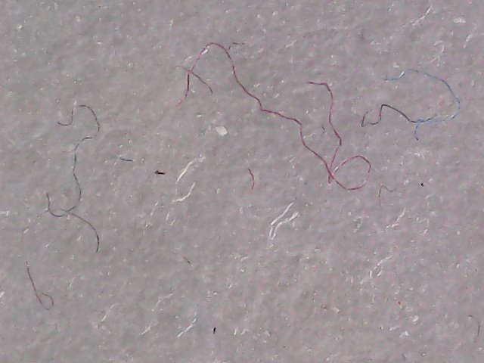
Living room Bathroom
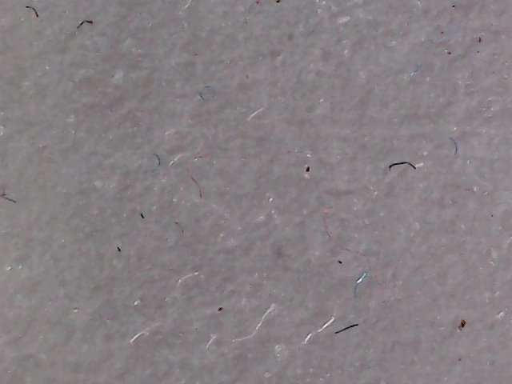
Bedroom
MARKS & TRACES
Fingermark Development
In this experiment we are going to look at two of the most commonly used techniques for development of fingerprints and try to recreate them in a ‘home’ environment. The two processes we will look at are powders, which have been used for over 110 years, and superglue fuming, which was discovered by accident in the late 1970s.

Powdering
The powders process works by fine powder particles selectively adhering to the fingermark ridges when they are brushed across a surface. Not all powders are suitable for use in this way, and some surfaces are better than others for powdering. We are going to investigate the effect of some of these variables on how well a fingermark can be developed by powdering.

Equipment
A soft brush (paint brush, make-up brush or similar)

Materials
Powders (a range of different powders of different colours and particle sizes, for example granulated sugar, castor sugar, icing sugar, cosmetic powders, custard powder, cocoa powder, cornflour)
Surfaces (try a range of different surfaces, for example a smooth non-porous surface such as a clear glass, a rougher surface such as a textured handle, a porous surface such as paper)

Method
Health & Safety Information: Only use powders that are non-toxic and avoid breathing in any fine dust. Powder lightly to avoid producing clouds of particles
- Select the surface you are going to use. Place one ‘natural’ fingermark onto the surface (a ‘natural’ fingermark is one deposited at least 30 minutes after washing hands and carrying out normal activities), and a ‘groomed’ fingermark next to it (a ‘groomed’ mark is produced after wiping the sides of the nose and forehead with the finger before deposition to build up a greasy deposit).

- Dip the tip of your brush into the powder you are going to use. Tap the brush gently to remove excess powder from it.

- Sweep the brush gently across the area of the surface that the fingermarks have been deposited in. Avoid pushing the brush into the surface, only a light contact is needed

- Build up the mark with multiple, gentle sweeps until you feel that you have the best contrast between the fingermark and the background (it is possible to ‘over-powder’ and start filling in the detail)

- Look at the developed marks and record the details in a table like this:

Type of powder | Type of surface | Development quality (good/fair/poor)
 |  | ‘Natural’ mark | ‘Groomed’ mark
e.g. icing sugar | e.g. glass | e.g. fair | e.g. good

Questions to consider
What types of powder work best?
What type of surface are powders most effective on?
What type of fingermark (natural/groomed) are powders most effective on?
Research the types of powder that are used by crime scene investigators to develop fingermarks. Which type of powder do you think the best performing powders from your study are most similar to?

Superglue fuming
As mentioned above, superglue fuming is a process that was discovered by accident in different parts of the world by people using superglue to repair items with enclosed spaces such as fishtanks. They observed that the vapours of the superglue developed fingermarks, and this was then pursued commercially by companies making specialist equipment to control the conditions required for fingerprint development.
We are also to try to develop fingermarks on materials using very basic equipment that you may find in the home. The superglue process works best when the water from the atmosphere is reabsorbed into the fingermarks, and the water in the fingermarks then acts as an initiator for a polymerisation reaction. In this case the molecules of the superglue (cyanoacrylate) form very fine fibres of polycyanoacrylate on the fingermark ridges. This is a white polymer, so it will be difficult so see on a white background.

Equipment
A large glass jar with a lid
Sellotape/Scotch tape
Aluminium foil
Hair dryer

Materials
Superglue (cyanoacrylate, free flowing liquid form rather than a gel)
Water
Surfaces (try a range of different surfaces, for example a clear non-porous surface such as a sandwich bag, a dark non-porous surface such as a black bin bag, a semi-porous surface such as a magazine cover)

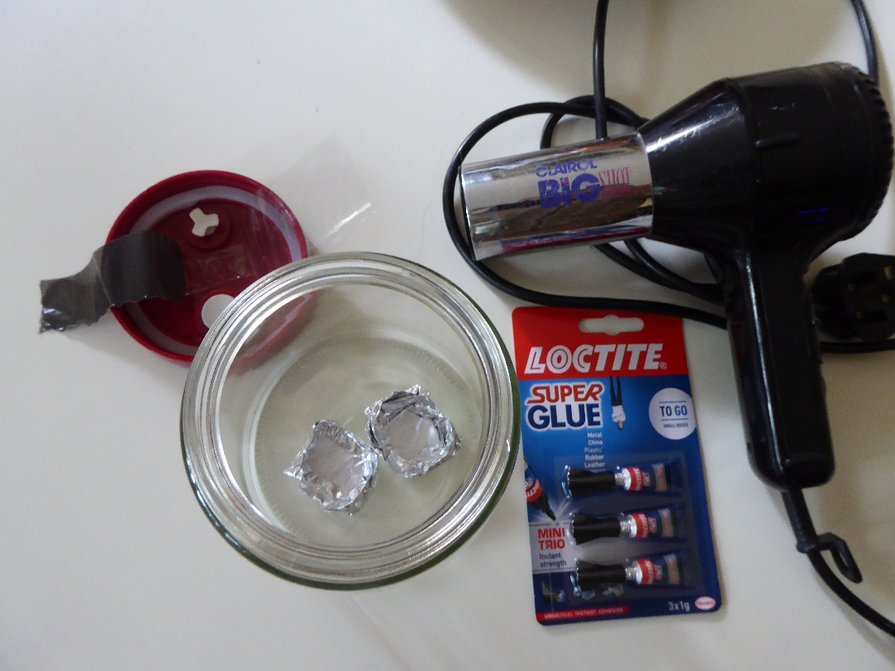

Method
Health & Safety Information: Superglue vapours can cause irritation and should not be breathed in. After treatment, the jar should be opened outside and left for 30 minutes for residual vapours to dissipate

- Select the surfaces you are going to use. Cut strips from the surfaces about 2 cm wide but 1 cm shorter than the height of the jar you are going to use.

- Place one ‘natural’ fingermark onto the surface (a ‘natural’ fingermark is one deposited at least 30 minutes after washing hands and carrying out normal activities), and a ‘groomed’ fingermark next to it (a ‘groomed’ mark is produced after wiping the sides of the nose and forehead with the finger before deposition).

- Stick the strips of your selected surfaces to the inside of the lid of the jar using the Sellotape, so that they will hang down into the jar but not touch the bottom.

- Take the aluminium foil and shape it to make two small, flat-bottomed aluminium dishes that will fit side by side on the bottom of the glass jar.

- In one of the dishes put 4-5 drops of superglue. In the other put ~10 drops of water.

- Screw the lid onto the jar. The surfaces should be hanging down in the jar, but not hanging into the aluminium foil dishes. If they are, unscrew the lid and trim the end of the strips with scissors.

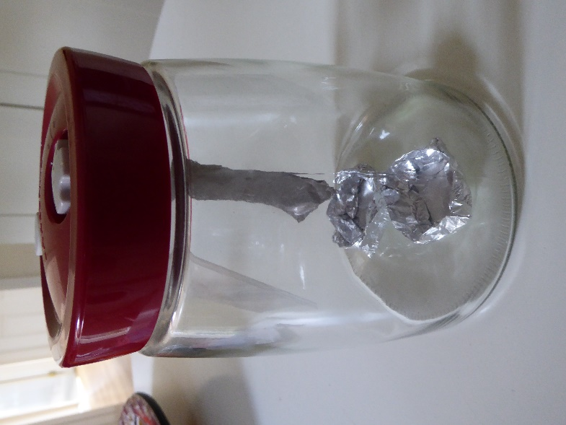
- Take a hair dryer and aim it at the bottom of the jar. Turn the hairdryer onto maximum heat and use it to heat the base of the jar for about 5 minutes. This should cause both the superglue and the water to create some vapour.

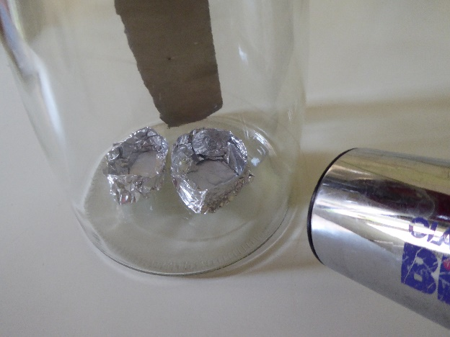

- Turn off the hairdryer and leave the jar for about an hour. At the end of that time, take it outside and unscrew the lid. Leave it outside for any residual fumes to disperse for about 30 minutes.

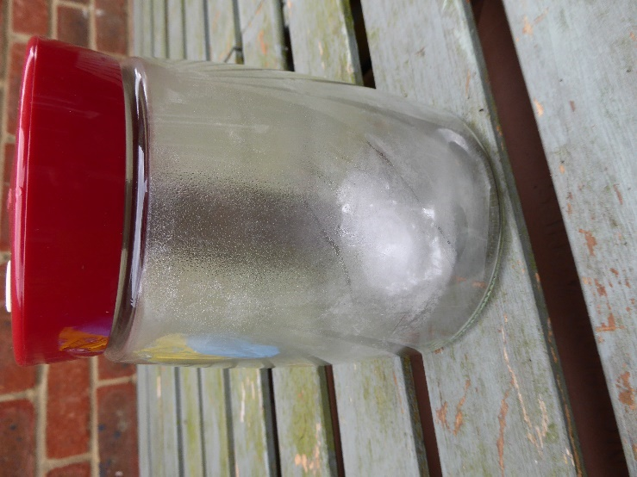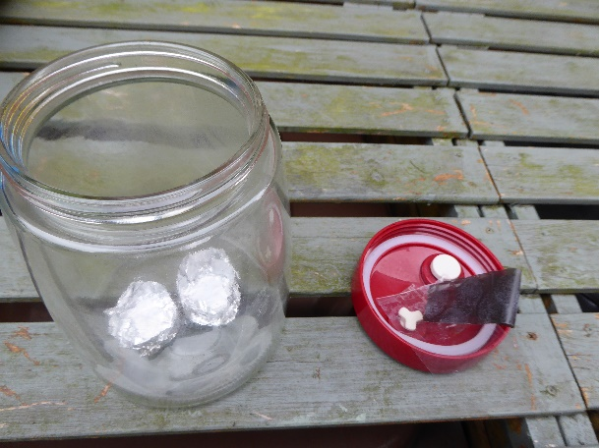

- Examine the fingermarks on the different surfaces and record your observations.
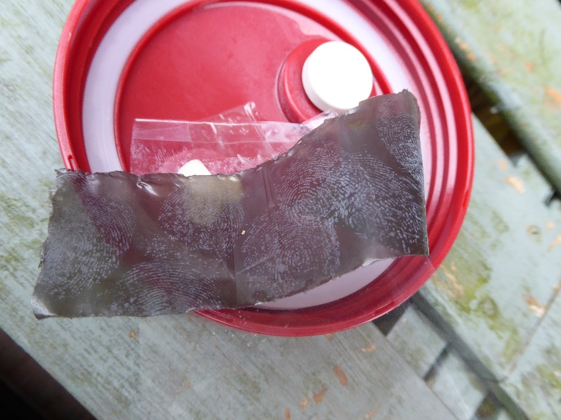
Type of surface | Development quality (good/fair/poor)
 | ‘Natural’ mark | ‘Groomed’ mark
e.g. black bin bag | e.g. fair | e.g. good

Questions to consider
What type of surface is superglue fuming most effective on?
What type of fingermark (natural/groomed) is superglue fuming most effective on?
Research the commercial equipment that is sold for superglue fuming. What conditions do they create in the chamber? How well do you think your improvised system did in recreating these conditions?

