非凡Fictional FUniversity of Birstall

MAND1234
Mandarin Chinese for Beginners
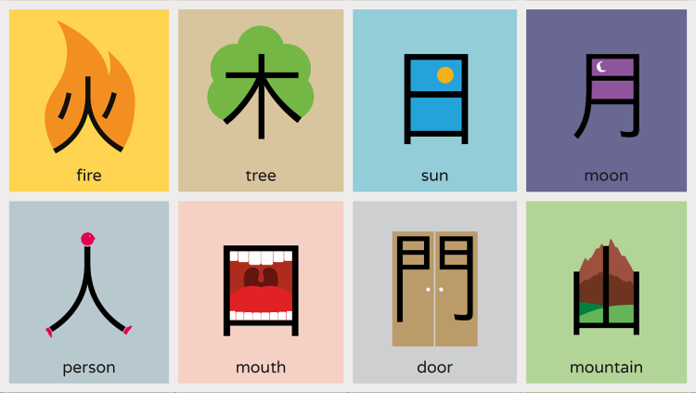
Remote learning workbook

Instructions for use:
I suggest that you use this document electronically, however you may want to print it out and write/draw into it. You’ll definitely need to do some hand-writing and hand-drawing throughout the module, because you’ll need to write some Chinese characters, so please either use pen/paper>photograph or please buy a stylus to use with an electronic device. You’ll also want to record some audio files and insert these, too, because pronunciation is very important. None of this has to be complicated - you can do all of this using your phone camera and voice recorder.
Have your workbook handy when attending online lectures and meeting with your personal tutor, so that you can screenshare your progress and you can identify and correct any mistakes.
Enjoy your learning – I can’t wait to meet you soon.
Dr Fei-Fan Tang, Module Leader
Module overview
Term 1
Staff | Topics | Term weeks
Dr Fei-Fan Tang  Contact details here | - Counting  - Tones  - Introducing yourself  - Family | 1,3,5,7,9
Dr Beth Rogoyski  Contact details here | - Pronunciation  - Chinese characters I  - Talking about where you work  - Colours | 2,4,6,8,10

Term 2
Staff | Topics | Term weeks
Dr TJ Moore  Contact details here | - Grammar  - Chinese characters II  - Asking questions | 15-20
Dr Nat Potiwat  Contact details here | - Sentence order  - Food and drink  - Directions | 21-25

Lecture notes
Dr Fei-Fan Tang
Lecture 1: Learning to count to five | Term week and date:
Learning outcomes:
to recognise the Chinese characters for the numbers 1-5
to be able to write the first three numbers using Chinese characters
to pronounce correctly the numbers 1-5
to spell correctly the numbers and add their tone markings
to correctly identify tones when heard aloud

Additional reading / first class learning outcomes:
to find out how to count from 6-10, with tones and characters

Pre-session work
Watch the video here and then complete the table below:
Number in English
Character in Mandarin | 一 | 二 | 三 | 四 | 五
Hand-written
Pinyin
Sounds like or rhymes with

Notes:

Live session work
Notes:

Homework
Carry out the additional reading work and then complete your lecture summary on the next page (either fill in the template, or delete this and insert your own alternative summary). Use it to check that you’ve met all of the learning outcomes for this session.

Dr Fei-Fan Tang Lecture 1 - Summary Sheet
Insert an audio clip here of you counting in Chinese. Speak slowly and make an effort to get the tone right.
You can also record your memory story!
Number in English | 1 | 2 | 3 | 4 | 5 | 6 | 7 | 8 | 9 | 10
Character |  |  |  | 四 | 五
Pinyin
Sounds like or rhymes with
Guide to writing the first three numbers in Chinese characters – try to get the stroke order correct
Summary of how the four tones are pronounced
First tone (e.g. ma)
Second tone (e.g. ma)
Third tone (e.g. ma)
Fourth tone (e.g. ma)
Appendix

How to insert a picture from your phone into this workbook
- Take the picture and send it to your laptop/device.
- Click wherever you want to insert the picture e.g. in a table
- Go to the insert toolbar > pictures
- You can then click the image and use the format toolbar to crop it, change the brightness and contrast and resize it
How to insert a voice recording from your phone into this workbook
- Make the recording and send it to your laptop/device. Tip – speak slower than you think you need to – by the time you come to revise, you might have forgotten some key information.
- Go to the insert toolbar > object (this is sometimes difficult to find – see screenshot below)
- Then click the from file tab – find your audio file and it will be inserted as a speaker symbol.
HERE’S AN EASIER WAY I THINK…
- Perhaps the easier way to do this is to insert a picture icon that means “sound file” to you. For example, I’ve used a microphone.
- Click right on the picture icon and then choose link.
- You’ll just be able to pick your audio file and when you click the picture it’ll play your audio file. You may need to change the file type to “all file types” from the drop-down menu.
Student experience and critical reflection on your own practice
You have been a student in this simulated remote learning experience. So, now you have two different perspectives to evaluate your experience; learner and lecturer. With your two different sets of glasses, please reflect on the following questions and then have a think about whether it might influence your thinking or practice about your own remote teaching…
Question | How did you feel as a student in this simulation? | What are your reflections as a lecturer about how this might influence your practice? How could the teacher Fei-Fan improve her practice?
Q1. How did you feel about starting off a new module / starting at university? Was there anything that helped? Was there anything that you didn’t like? What else could the lecturer have done to help?
Q2. How did you find using the student workbook? Was it helpful or not? Did you use it?

Q3. How did you feel about the flipped classroom method? Was it helpful or not? Did you do the pre-work? Do you think that more was learned using this method?
Q4. How did you feel about the group work? Was it helpful or not? How could it be improved?
Q5. How did you feel about active learning? How would you compare Bb collaborate with Turning Point? How else could Fei Fan have got students being active?
Q6. What were your personal feelings about this remote learning experience? Did you discover anything interesting, surprising, expected or unexpected about how you felt? Did Fei-Fan do anything to make you feel better or worse?
Other questions / notes…

